

Use Case Specification: Quality eCL Submission
For
eCoaching Log

Change History Log

Date | Version | Description | Author
08/05/2014 | 1.0 | Initial Document | Doug Stearns
08/08/2014 | 1.1 | Updates from review | Doug Stearns
09/09/2014 | 1.2 | Updates from additional review and phase 2 development | Doug Stearns
10/10/2014 | 1.3 | P13479 – eCL Warning Log for CSR  Still more additional requirements | Doug Stearns
10/24/2017 | 1.5 | P13609 – ecl for Quality Alignment Specialists  Updated 3.4 to add WACQ03  Updated 7.1 to more WACQ03 from lead to specialist | Doug Stearns
02/17/2015 | 1.6 | P14323 – eCL No self coaching log  Updated 3.4 so that submitters can’t submit logs to themselves | Doug Stearns
02/19/2015 | 1.7 | P14323 – eCL No self coaching log  Modified 3.4 | Doug Stearns
09/02/2015 | 1.8 | TFS667 – eCL WPOP70 submit all modules  Updated 7.1 – added WPOP70 to others | Doug Stearns
07/29/2016 | 1.9 | TFS3440 – eCL Job Code Submission Permission  Updated 7.1 | Doug Stearns

Table of Contents

1. Brief Description 6
2. Participating Actors 6
2.1 Primary 6
2.2 Secondary 6
3. Basic Flow of Events 7
3.1 Identify coachable event. 7
3.2 Access eCoaching Log website submission page. 7
3.3 Select Quality module. 7
3.4 Select the appropriate specialist (required selection) 7
3.5 Select the appropriate program (required selection) 7
3.6 Select the coaching delivery option (required selection). Select Yes to deliver coaching. 7
3.7 Enter or select the date of coaching (required selection) 7
3.8 Customer Service Escalation (default to No; disabled) 7
3.9 Select applicable coaching reasons, whether opportunity or reinforcement, and applicable sub-coaching reasons (required selection) 7
3.10 Enter details of the behavior to be coached (required entry; free form text up to 3000 characters) 8
3.11 Enter details from the coaching session including action plans developed (required entry; free form text up to 3000 characters). Note: Yes selected in 3.6 (not available if No selected). 8
3.12 Select how the coaching opportunity was identified (required selection) 8
3.13 Select if there is a Call Record associated with this coaching (required selection; default to No) 9
3.14 Select to verify that all information on the form is true and complete (required selection) 9
3.15 Submit the Quality eCoaching Log 9
4. Alternative Flows 10
4.1 Select the coaching delivery option. [Step 3.6] 10
4.2 Select if Call Record is associated with this coaching (Yes selected). [Step 3.13] 10
5. Preconditions 10
5.1 eCoaching Log website available. 10
5.2 eCoaching Log database available. 10
5.3 eCoaching Log database populated with correct and current hierarchy information for Quality Specialists, Quality Leads, Deputy Program Manager. 10
6. Postconditions 10
6.1 eCoaching Log submitted. 10
6.2 eMail notifications sent appropriately. 10
7. Assumptions and Dependencies 10
7.1 Access to Quality module will be limited to those with the following job codes: 10
8. Business Rules 11
8.1 none 11
9. Technical Requirements 11
9.1 none 11
10. Activity Diagrams 12

Table of Figures
Figure 1 – Quality eCL Submission 12

Brief Description
Allow eCoaching Logs for call center Quality Specialists.

Participating Actors

Primary

Quality Specialists

Quality Leads

Secondary

Deputy Program Manager

Basic Flow of Events

Identify coachable event.

Access eCoaching Log website submission page.

Select Quality module.

Select the appropriate specialist (required selection)

Specialists displayed will be those with job codes of WACQ02, WACQ03 and WACQ12. Submitters of logs will not be available for selection from the list of Quality Specialists.

Select the appropriate program (required selection)

Possible programs are:
Marketplace
Medicare
NA

Select the coaching delivery option (required selection). Select Yes to deliver coaching.

Possible options are:
Yes, I will be delivering the coaching session
No, I will not be delivering the coaching session

Enter or select the date of coaching (required selection)

Customer Service Escalation (default to No; disabled)

Select applicable coaching reasons, whether opportunity or reinforcement, and applicable sub-coaching reasons (required selection)

Possible options are:
Coaching Reason | Opportunity and Reinforcement
- Sub-Coaching Reason
ATA Alignment | Opportunity and Reinforcement
- Administrative Procedures
- Agent Responsiveness
- Closing QA Team Notes
- Conversation Management
- Disclosure
- Opening
- Professional Etiquette
- Program Knowledge
- Reasons for Call
- Other: Specify reason under coaching details.
Attendance | Opportunity and Reinforcement
- Other: Specify reason under coaching details.
Call Quality | Opportunity and Reinforcement
- Call Listening Completions
- Special Assignment Completions
- Other: Specify reason under coaching details.
Corporate / Program Initiatives | Opportunity and Reinforcement
- Calibration Attendance and Completion
- Required Training
- TCA Duties
- Other: Specify reason under coaching details.
Escalation | Opportunity
- Other: Specify reason under coaching details.
Professional Conduct | Opportunity and Reinforcement
- HR Guidelines
- Other: Specify reason under coaching details.
Recognition | Reinforcement
- CSR Certification
- Kudos
- Other: Specify reason under coaching details.
Secure Floor Violation | Opportunity and Reinforcement
- CoR
- Other: Specify reason under coaching details.
Weekly Productivity | Opportunity and Reinforcement
- ATA Completions
- Call Listening
- Monitors
- Phone Support
- Target Monitoring Team
- Other: Specify reason under coaching details.

Enter details of the behavior to be coached (required entry; free form text up to 3000 characters)

Enter details from the coaching session including action plans developed (required entry; free form text up to 3000 characters). Note: Yes selected in 3.6 (not available if No selected).

Select how the coaching opportunity was identified (required selection)

Possible options are:
CMS Reported Item
CSR Report Issue
Internal CCO Reporting
Leadership Listening
Manager Coaching
Quality Call Listening
Supervisor Coaching
Training and Development
Verint Quality Monitoring
Walk-By

Select if there is a Call Record associated with this coaching (required selection; default to No)

Possible options are:
Yes
No

Select to verify that all information on the form is true and complete (required selection)

Submit the Quality eCoaching Log

Alternative Flows

Select the coaching delivery option. [Step 3.6]

Select No to not deliver coaching session.

Continue with steps 3.7 through 3.10 above, skip 3.11.

Continue with Step 3.12 above.

Select if Call Record is associated with this coaching (Yes selected). [Step 3.13]

Select Yes call record is available.

Select the applicable call record source

Possible options are:
Verint
NGD ID
Avoke
UCID

Enter the appropriate identifier value for selected option

Continue with Step 3.14 above

Preconditions

eCoaching Log website available.

eCoaching Log database available.

eCoaching Log database populated with correct and current hierarchy information for Quality Specialists, Quality Leads, Deputy Program Manager.

Postconditions

eCoaching Log submitted.

eMail notifications sent appropriately.

Assumptions and Dependencies

Access to Quality module will be limited to those with the following job codes:
Specialist / Other | WACQ02, WACQ03, WACQ12, WPPM12, WPPM13
Supervisor / Lead | WACQ13, WACQ40
Manager | WSQA50, WEEX90, WEEX91, WSQA70
Others | WPOP70, Program Staff Systems Analyst, Software Engineer, Testing Engineer

Business Rules

none

Technical Requirements

none

Activity Diagrams
Below is the activity diagram for the use case that provides a visual depiction of the flow of events.

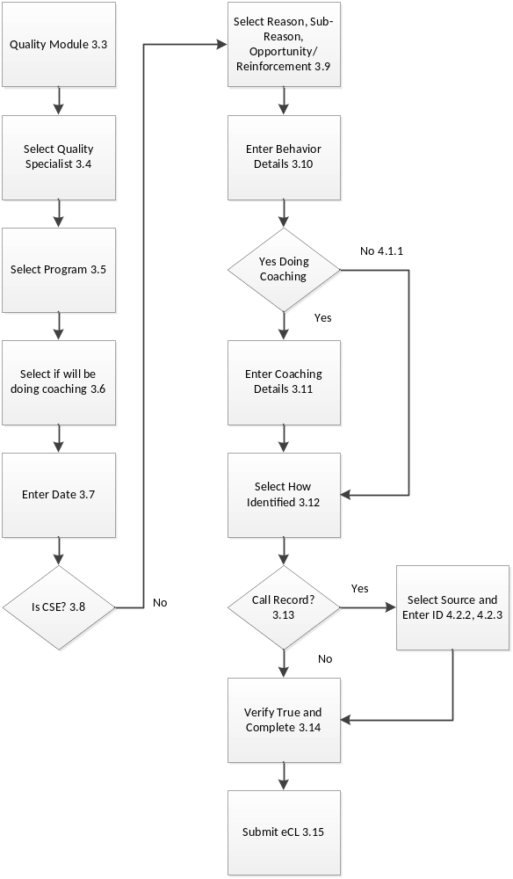

Figure 1 – Quality eCL Submission

